Retail Store Sales Data Analysis Project
End-to-End Analysis: SQL Server, Python, and Power BI

1. Project Overview
This project presents a complete data analysis workflow for retail store sales data, covering the full pipeline from database design to final reporting. The work was carried out in three main stages: building a relational database and writing analytical queries in SQL Server, cleaning and preparing the data using Python, and designing an interactive Power BI dashboard to present business insights.
The goal of the project was to turn raw transactional data (sales, returns, products, customers, and stores) into clear, actionable insights that support business decision-making, covering overall performance, product and sales trends, customer behavior, and regional performance.

2. Database Design and SQL Development

2.1 Schema Design
A relational database named Retail_Store_DB was built in SQL Server. Given the nature of the data, a Galaxy Schema was chosen, using two fact tables that share a common set of dimension tables:
- FactSales – records individual sales transactions (date, product, customer, store, quantity).
- FactReturns – records returned items (date, product, store, quantity).
- Shared dimension tables: DimProducts, DimCustomers, DimStores, and DimCalendar.

2.2 Data Integration
Two data integration steps were carried out to simplify the model and make analysis easier:
- Merging sales history: the source data contained separate sales tables for 1997 and 1998 (FactSales1997 and FactSales1998). These were combined using a UNION ALL query and loaded into a single FactSales table.
- Merging store and region data: the original Stores and Region tables shared only two relevant columns. These were merged into a single dimension table, DimStores_Final, to make store and region attributes easier to use in analysis.
- After merging, the foreign key constraints on FactSales and FactReturns were updated to reference the new DimStores_Final table instead of the original DimStores table.

2.3 Views and Calculated Measures
Two SQL views were created to simplify reporting and analysis, one for each fact table. Each view joins the fact table with the key columns needed from its related dimensions, and adds calculated revenue and profit measures directly in the query:
- v_FactSales – joins sales data with product, customer, and store attributes, and calculates Total_Revenue, Total_Cost, and Net_Profit.
- v_FactReturns – joins returns data with product and store attributes, and calculates Returned_Revenue and Returned_Cost.
These views were used as the main data source for the business questions and for the Power BI dashboard.

2.4 Business Questions
Key business insights were translated into a structured set of analytical questions, and each question was answered with a dedicated SQL query (file: Business_Questions.sql). The questions were grouped by dashboard page, and each query result was mapped to a specific KPI, chart, or table:
- Executive Overview – underperforming products, top revenue-generating brands, underperforming sales regions, overall return rate, and yearly returns volume.
- Sales & Product Analysis – average order value over time, top revenue-generating products, most-returned product brands, and net profit versus cost by product.
- Customer Analysis – revenue by occupation, average order value by education level, spending by homeownership status, customer segmentation by income, and purchasing volume by membership card type.
- Regional Analysis – sales distribution by country, top-performing cities, performance by sales region, and revenue by store type.
A separate set of validation queries was also written to confirm the core dashboard KPIs, including total sales, total orders, average order value, total net profit, return rate, and year-over-year and month-over-month growth.

3. Data Cleaning and Preparation (Python)
The source dataset was delivered as a set of separate CSV files (Customers, Products, Stores, Region, Calendar, Sales 1997, Sales 1998, and Returns). Python was used to load this data into SQL Server and to check and fix data quality issues before analysis. The work was organized into three notebooks.

3.1 Loading the Data
Most CSV files were loaded directly into their corresponding SQL Server tables by wizzard.
The DimCustomers table required a custom Python script (Load_Data.ipynb), using pandas and SQLAlchemy, to connect to the database and load the data programmatically. Date columns (birthdate and account-opening date) were cleaned and converted to a proper date format before loading, with any invalid or missing dates set to a default placeholder date.

3.2 Detecting Missing Values
All eight dataset files were scanned with pandas (Missing_Values.ipynb) to check for missing values in every column, with the number and percentage of missing values reported per column. This check identified two issues:
- 1 missing value in the last_name column of the Customers data.
- 687 missing values in the recyclable column and 1,008 missing values in the low_fat column of the Products data.
No missing values were found in the remaining files (Stores, Region, Calendar, Sales 1997, Sales 1998, and Returns).

3.3 Handling Missing Values
The identified issues were resolved in Handle_Missing_Values.ipynb:
- The missing last_name value was filled with “Unknown”.
- The missing recyclable and low_fat values were filled with 0 and converted to integer type.
The cleaned files were then saved back to CSV, ready to be loaded into the database.

4. Power BI Dashboard

4.1 Data Connection and Modeling
Power BI was connected directly to the Retail_Store_DB database in SQL Server. The relationships between the fact tables (FactSales and FactReturns) and their dimension tables were built inside Power BI, reflecting the galaxy schema designed in SQL Server. Year and Month columns were added to the DimCalendar table to support time-based analysis.

4.2 DAX Measures
All key measures were calculated using DAX and organized into logical folders for clarity:
- In FactSales: Core KPIs, Customer & Regional KPIs, and Time KPIs.
- In FactReturns: Returns Analysis KPIs.

4.3 Dashboard Pages
The dashboard contains five pages. Each page answers a specific group of business questions using KPIs and charts driven directly by the SQL queries described in Section 2.4.

Home
The landing page shows the overall business totals — Total Revenue, Total Net Profit, Total Cost, Returned Revenue, Returned Cost, and Returned Quantity — along with navigation buttons to move between the other four pages.
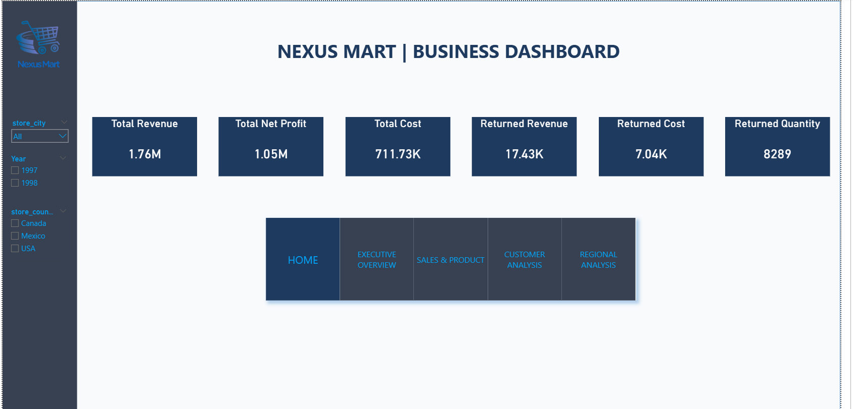
Home page

Executive Overview
This page summarizes overall business health: year-over-year and month-over-month revenue growth, total net profit and revenue, the lowest-performing products, the yearly return rate, and the weakest-performing sales regions, along with total revenue by product brand.
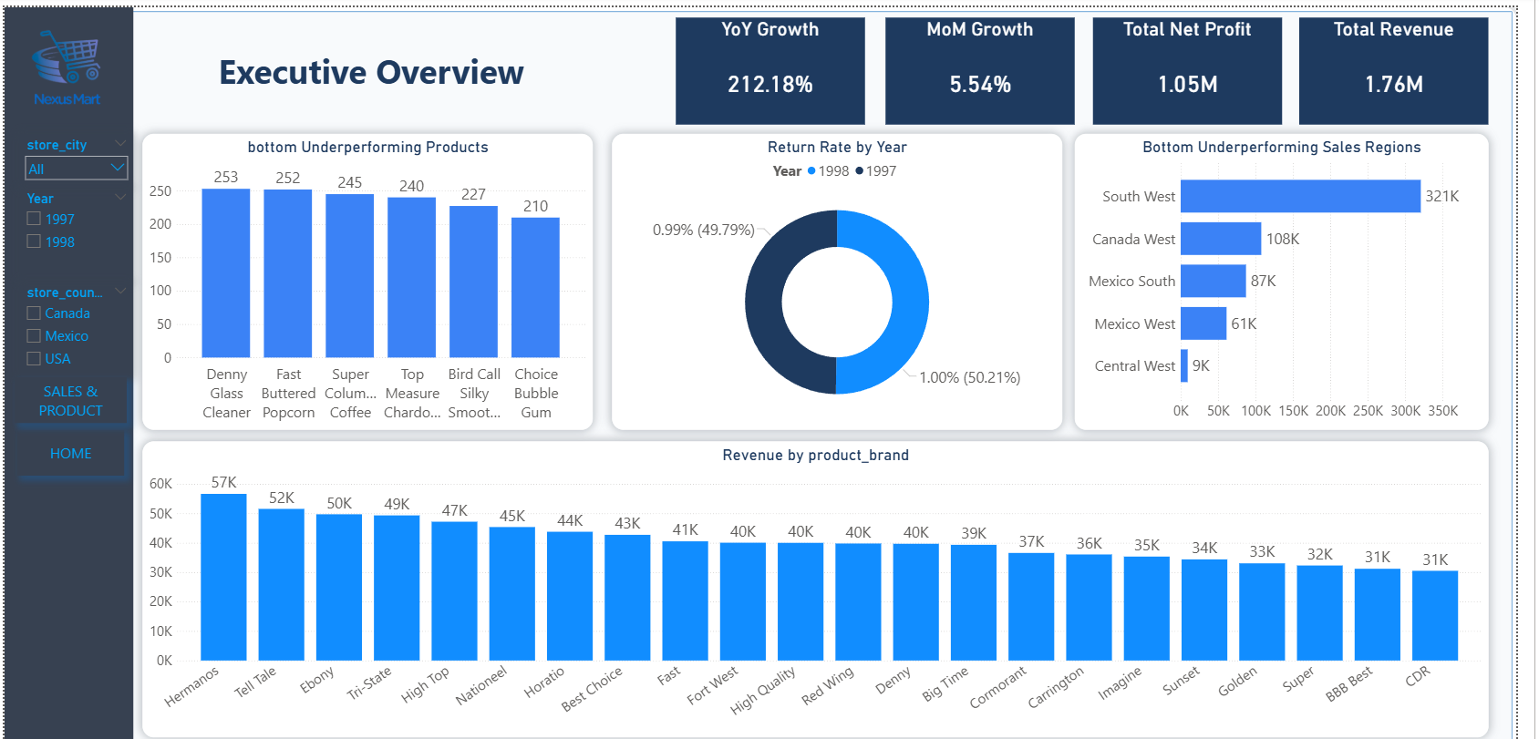
Executive Overview page

Sales & Product
This page focuses on product and order-level performance: total returns and return rate, average order value, the top revenue-generating products, the product brands with the highest returned quantities, and a comparison of net profit versus cost for the top products.
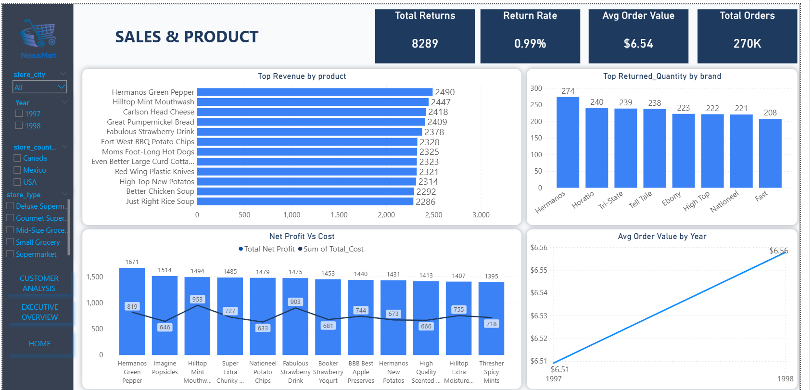
Sales & Product page

Customer Analysis
This page explores customer behavior: average spending per customer, total customers, average order value by education level, revenue by homeownership status, top revenue by occupation, customer segmentation by yearly income, and revenue by membership card type.
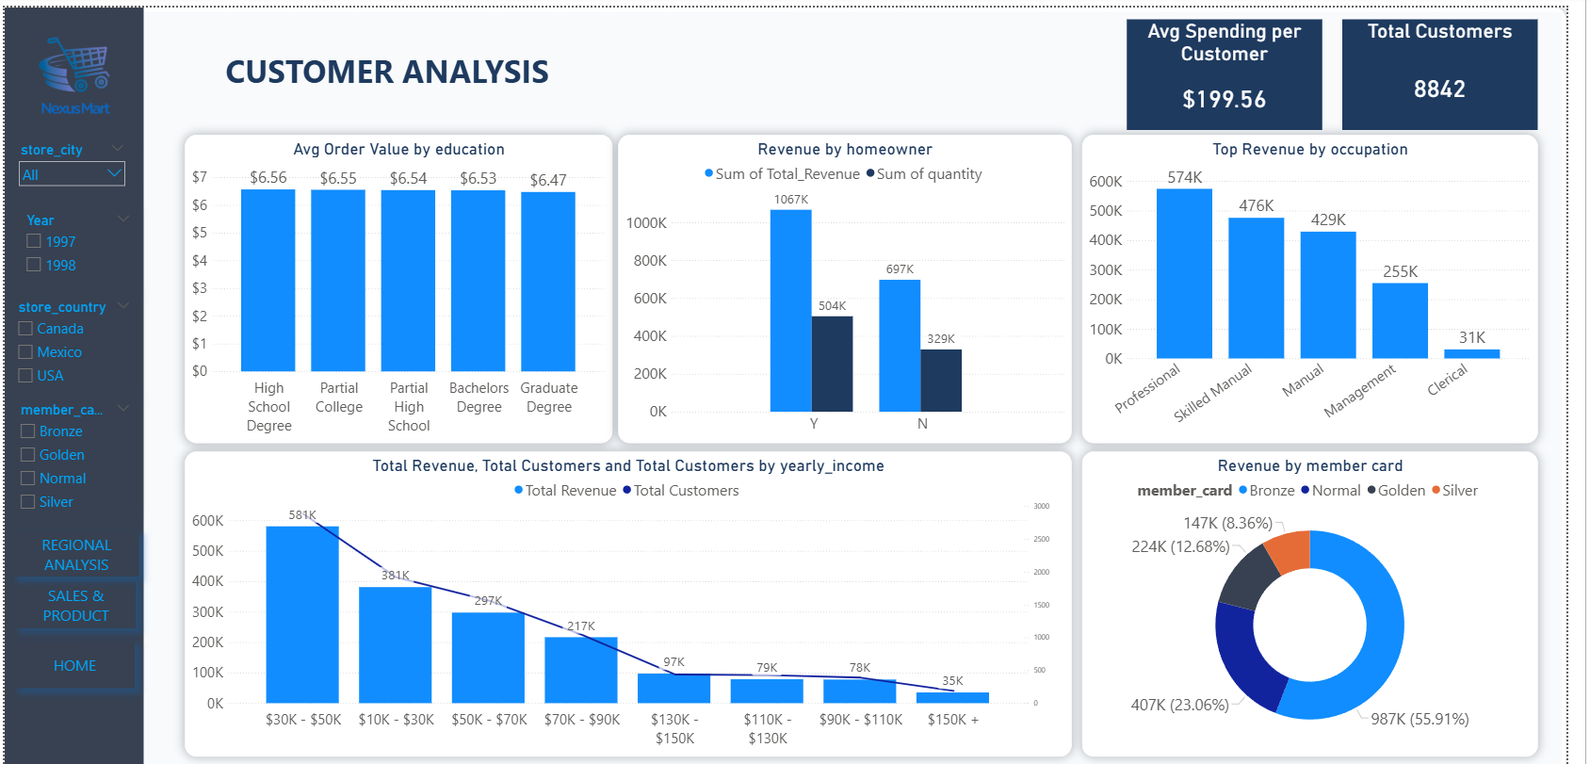
Customer Analysis page

Regional Analysis
This page presents geographic performance: average revenue per store, total number of stores, revenue by country, revenue by store type, revenue and net profit by sales region, and revenue by city.
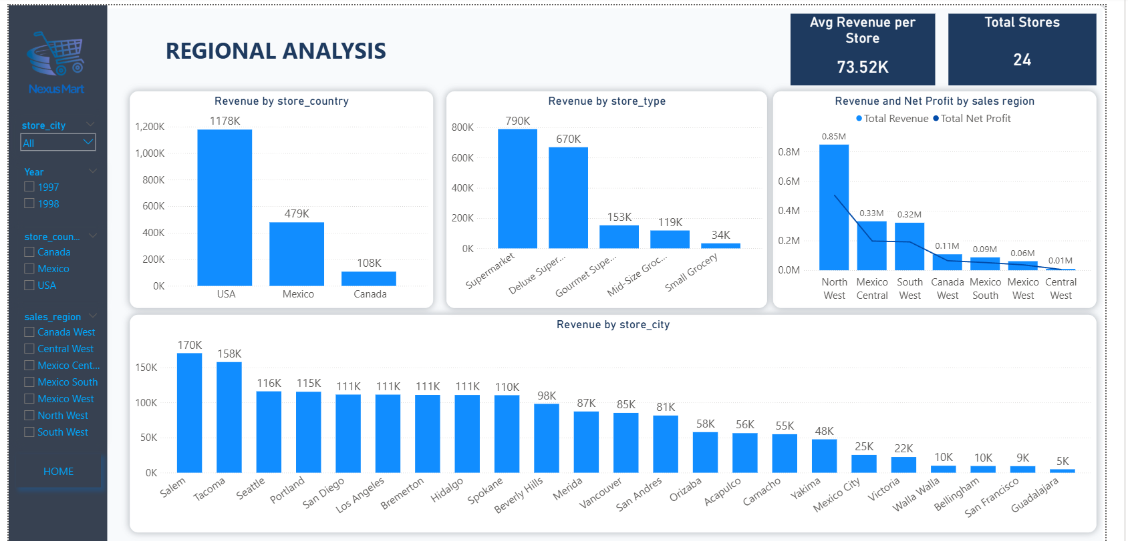
Regional Analysis page

4.4 Design Choices
- A light gray and blue color palette was used throughout the dashboard to keep it clean and easy on the eyes.
- Navigation buttons were added to all pages for quick movement between sections.

5. Conclusion
This project covered the full data analysis lifecycle: designing a galaxy-schema database in SQL Server, integrating and cleaning the source data with Python, writing SQL views and business-question queries, and presenting the results through an interactive five-page Power BI dashboard. Together, these stages turned raw sales, returns, customer, and store data into a structured set of insights covering overall business performance, product and sales trends, customer behavior, and regional performance.

